Serial Architecture Robot Examples: Instantaneous Kinematics (Jacobian)

Example 1
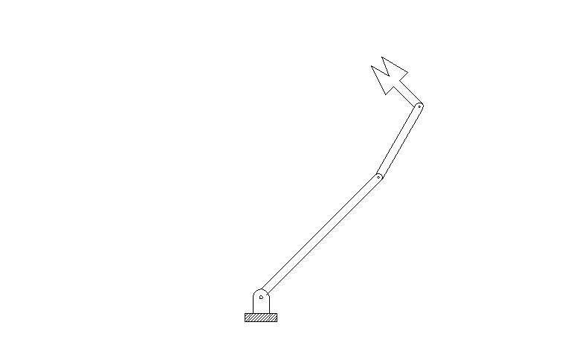
x₀
z₀
x₁
z₁
x₂
z₂
z₃
x₃

i | a_{i} | α_{i} | d_{i} | θ_{i}
1 | l₁ | 0 | 0 | θ₁*
2 | l₂ | 0 | 0 | θ₂*
3 | l₃ | 0 | 0 | θ₃*
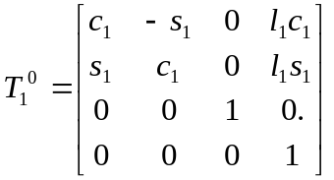,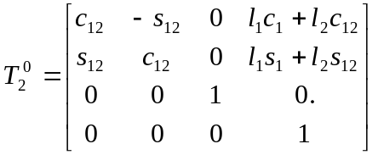,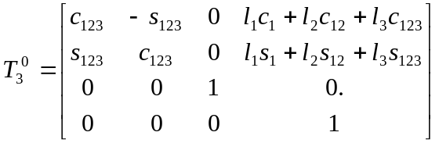
with
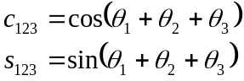, etc.

Determine Manipulator Jacobian: J_{6x3}
Joint 1 is revolute:
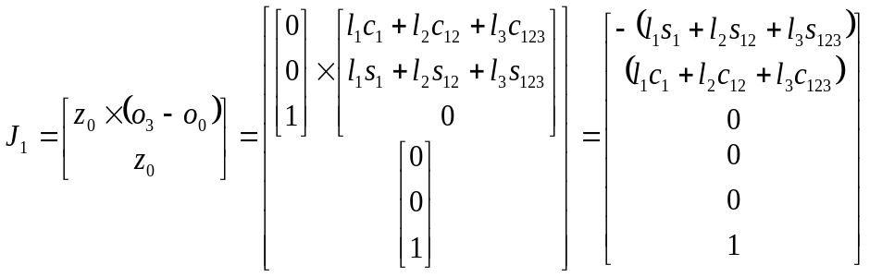

Joint 2 is revolute:
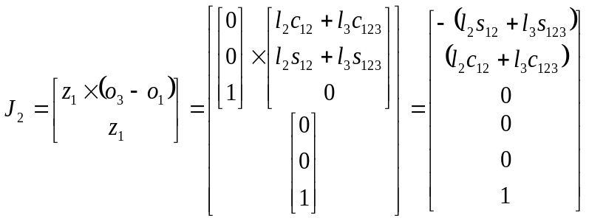

Joint 3 is revolute:
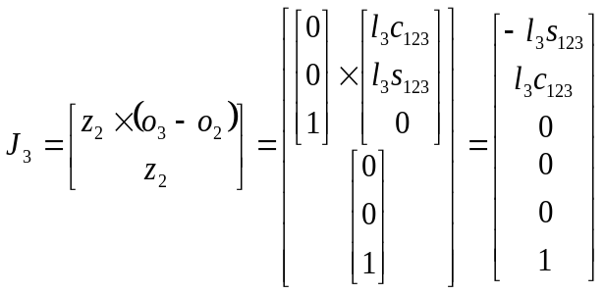
Jacobain:

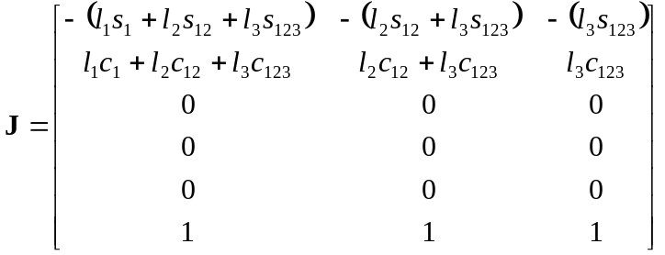
Example 2
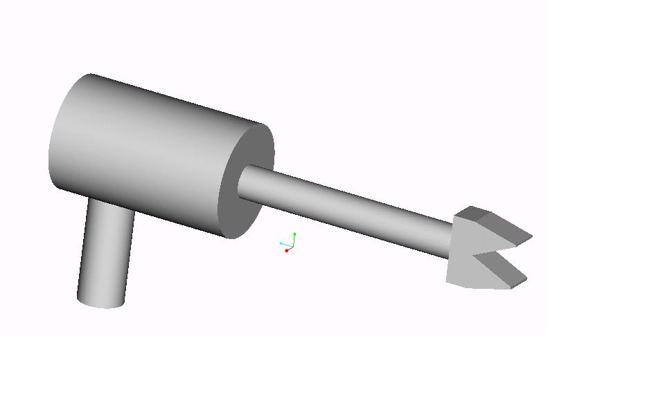
J₂
J₃
J₁
x₀
z₀
x₁
z₁
x₂
z₂
z₃
x₃
d₃
d₂
d₁
J₂
J₃
J₁

i | a_{i} | α_{i} | d_{i} | θ_{i}
1 | 0 | 90 | d₁ | θ₁*
2 | 0 | 0 | d₂* | 0
3 | 0 | 0 | d₃ | θ₃*
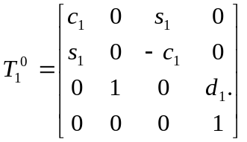,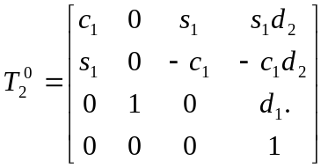,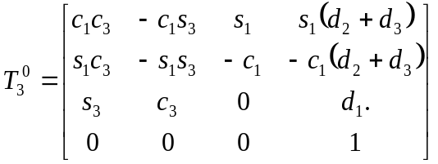

Determine Manipulator Jacobian: J_{6x3}
Joint 1 is revolute:
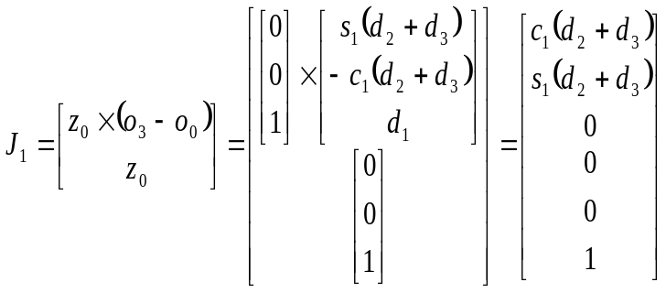

Joint 2 is prismatic:
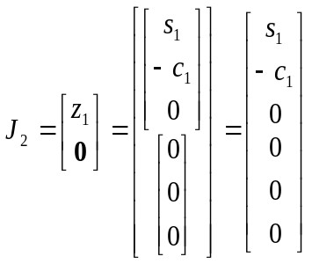

Joint 3 is revolute:
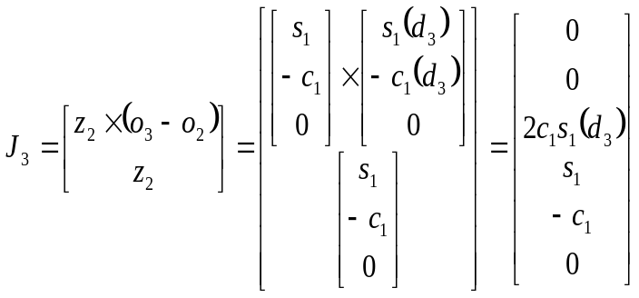

Jacobian:
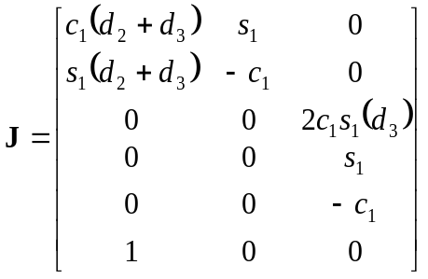

Example 3
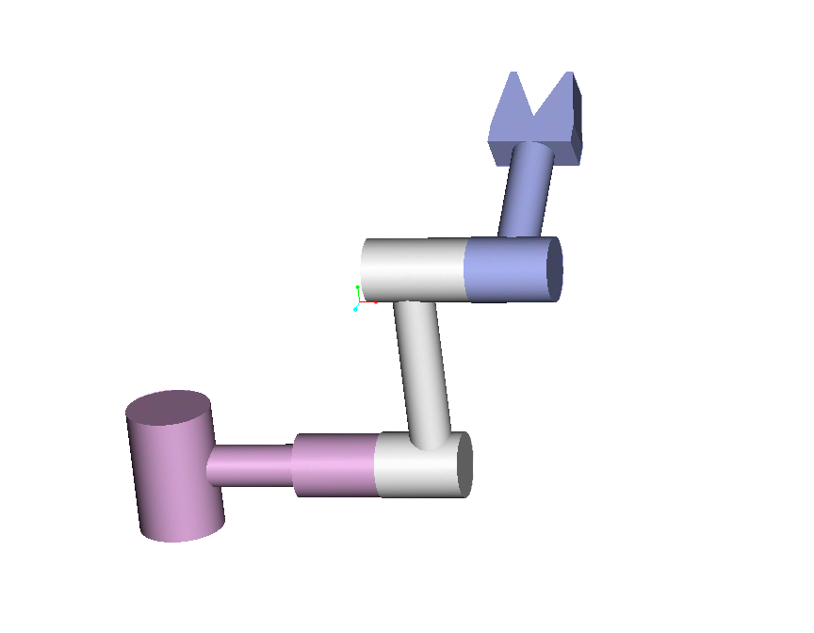
J₃
x₀
z₀
x₁
z₁
x₂
z₂
z₃
x₃
a₃
a₂
d₁
d₃
i | a_{i} | α_{i} | d_{i} | θ_{i}
1 | 0 | 90 | d₁ | θ₁*
2 | a₂ | 0 | 0 | θ₂*
3 | a₃ | 0 | d₃ | θ₃*
,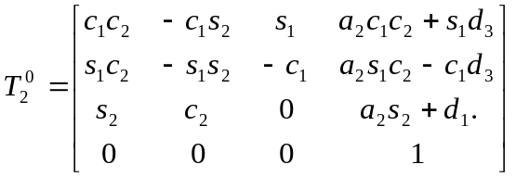,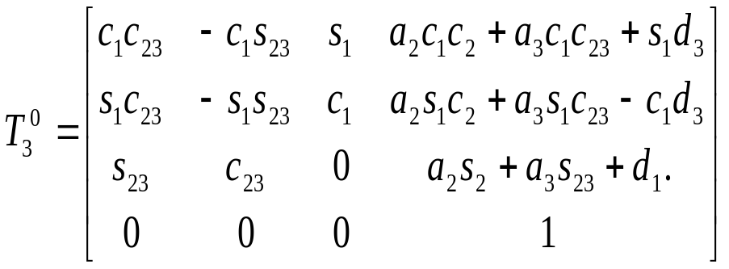
with
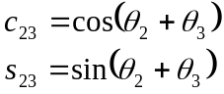

Determine Manipulator Jacobian: J_{6x3}
Joint 1 is revolute:
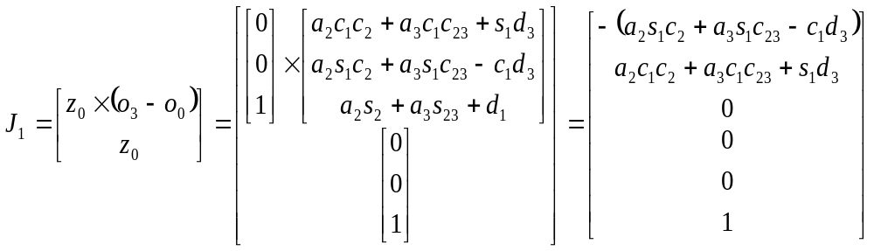

Joint 2 is revolute:
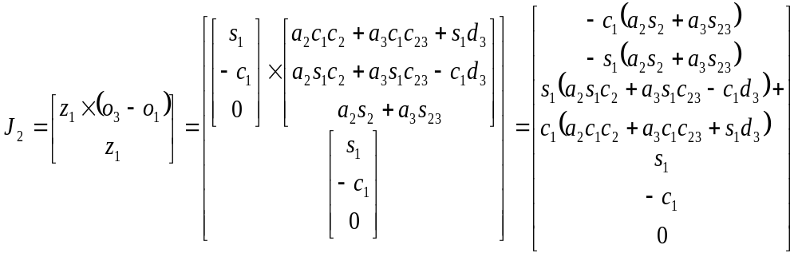

Joint 3 is revolute:
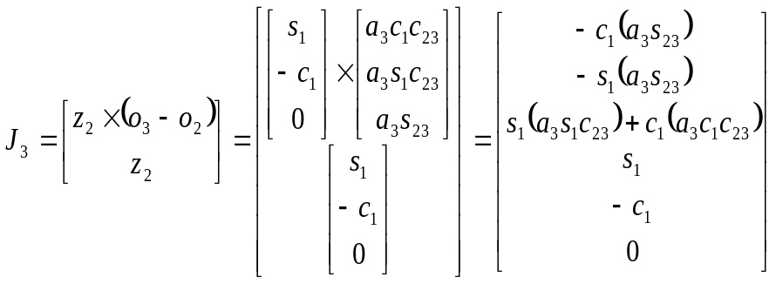
Jacobian:

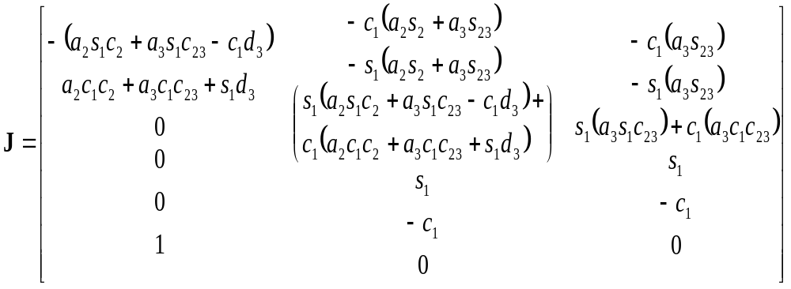
Example 4 : Spherical Wrist
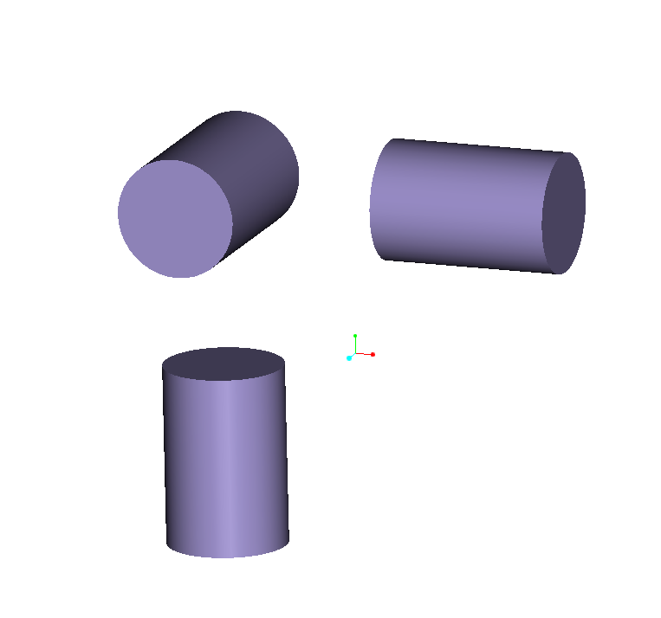
x₀
z₀
x₁
z₁
x₂
z₂
z₃
x₃
θ₃
d₁
d₃
i | a_{i} | α_{i} | d_{i} | θ_{i}
1 | 0 | 90 | d₁ | θ₁*
2 | 0 | 90 | 0 | θ₂*
3 | 0 | 0 | d₃ | θ₃*
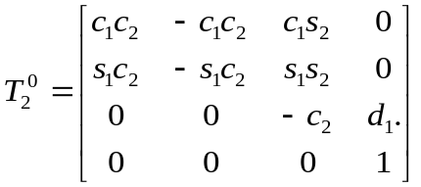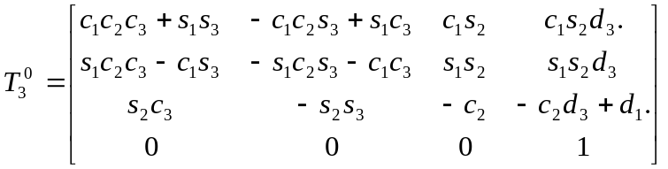

Determine Manipulator Jacobian: J_{6x3}
Joint 1 is revolute:
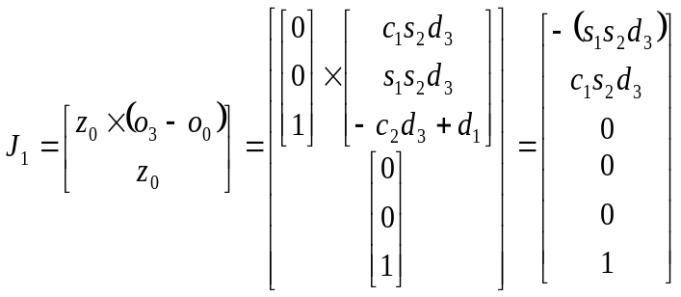

Joint 2 is revolute:
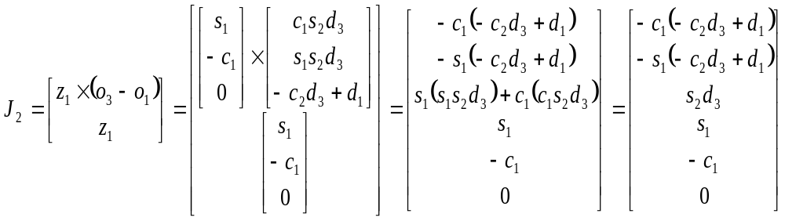

Joint 3 is revolute:
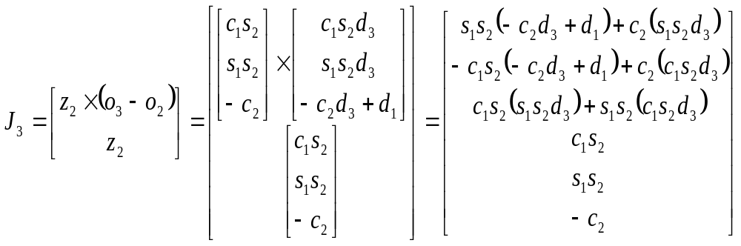

Jacobian:
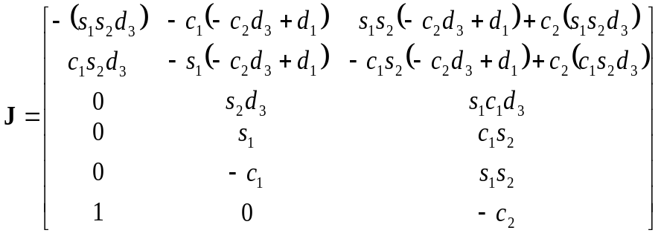
Singularities:
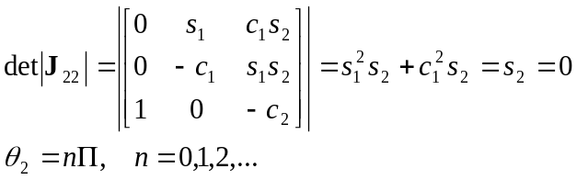
Example 5
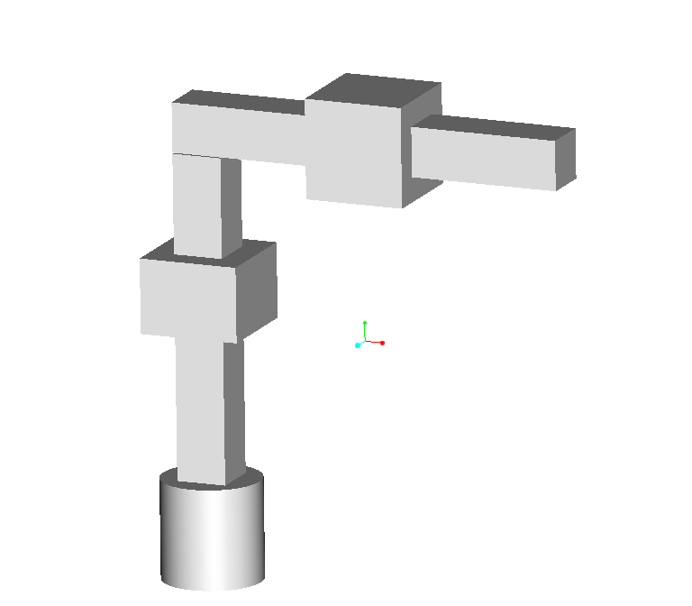
x₀
z₀
x₁
z₁
x₂
z₂
z₃
x₃
d₁
d₃
d₂
i | a_{i} | α_{i} | d_{i} | θ_{i}
1 | 0 | 0 | d₁ | θ₁*
2 | 0 | 90 | d₂* | 0
3 | 0 | 0 | d₃* | 0
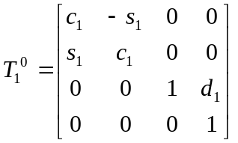,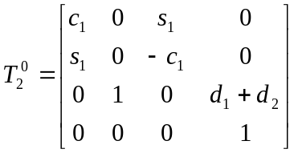,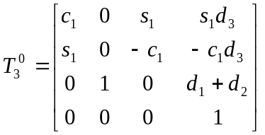

Determine Manipulator Jacobian: J_{6x3}

Joint 1 is revolute:
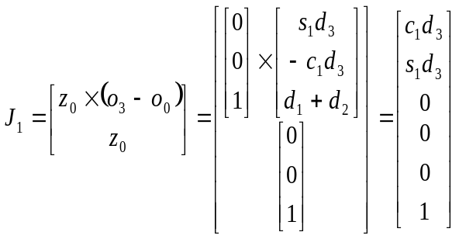

Joint 2 is prismatic:
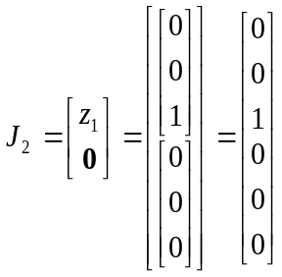

Joint 3 is prismatic:
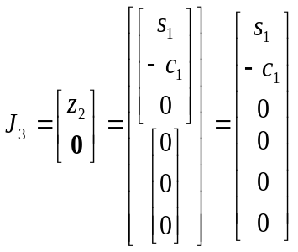

Jacobian:
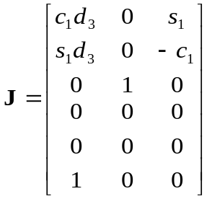
Example 6:

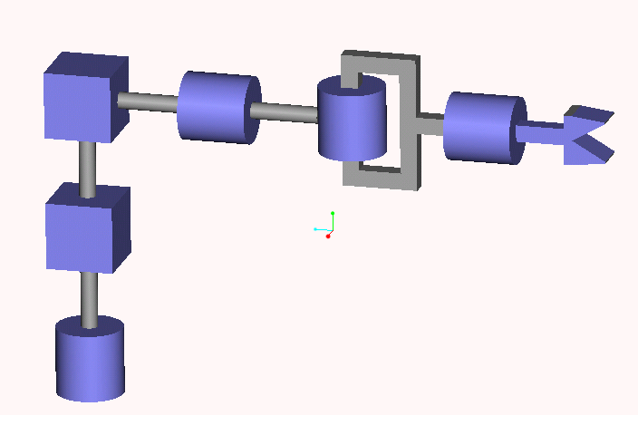
x₀
z₀
x₁
z₁
x₂
z₂
z₃
x₃
d₁
d₃
z₄
x₄
x₅
x₆
z₆
z₅
d₂
d₆
i | a_{i} | α_{i} | d_{i} | θ_{i}
1 | 0 | 0 | d₁ | θ₁*
2 | 0 | 90 | d₂* | 0
3 | 0 | 0 | d₃* | 0
4 | 0 | -90 | 0 | θ₄*
5 | 0 | 90 | 0 | θ₅*
6 | 0 | 0 | d₆ | θ₆*
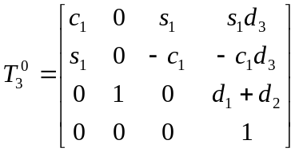

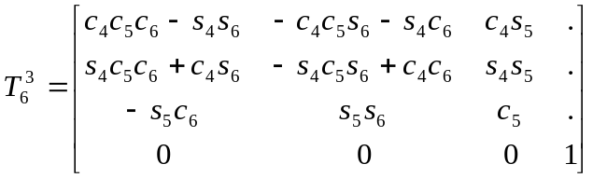
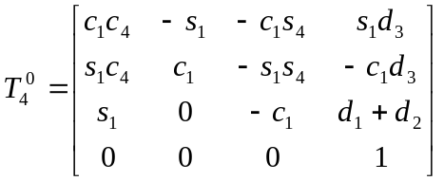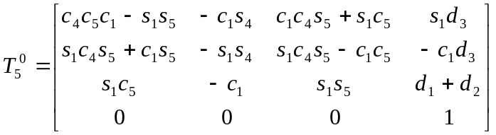
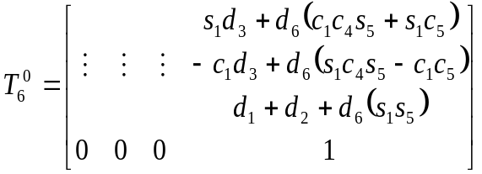

Determine Manipulator Jacobian: J_{6x6}

Joint 1 is revolute:
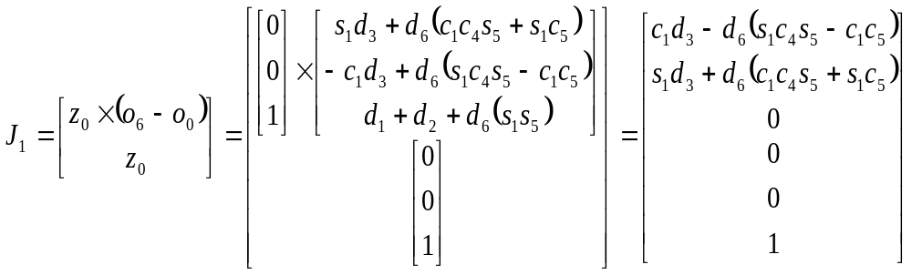

Joint 2 is prismatic:
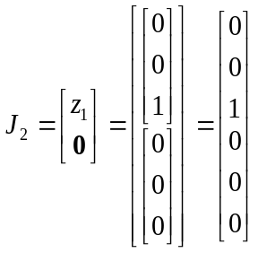

Joint 3 is prismatic:
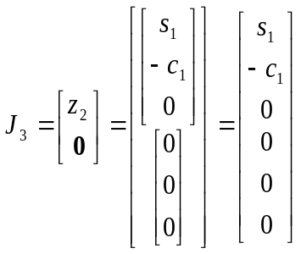
Joint 4 is revolute:
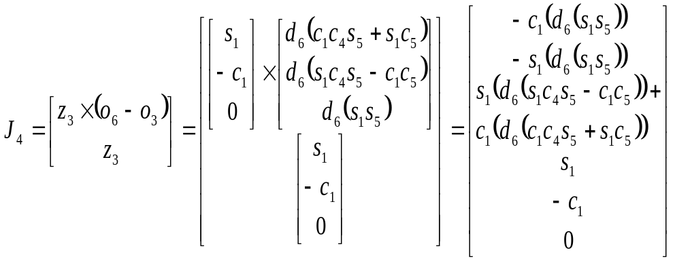
Joint 5 is revolute:
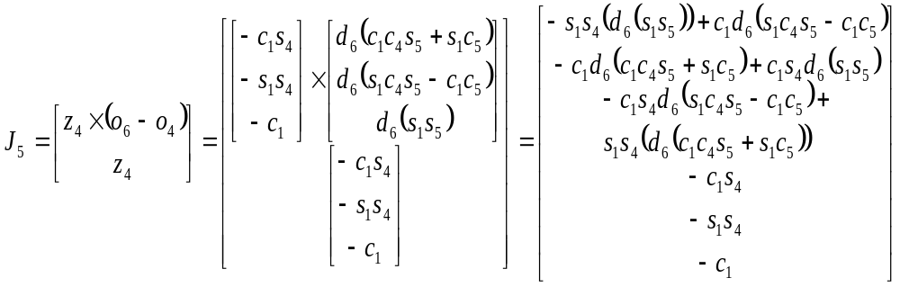
Joint 6 is revolute:
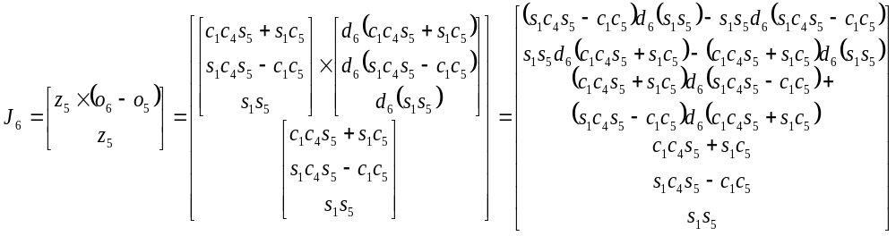
Jacobian:
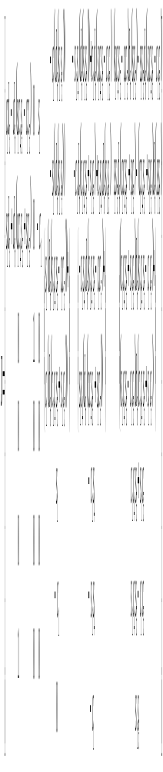Partition:
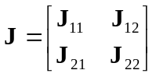
with:
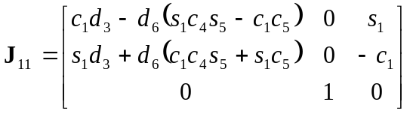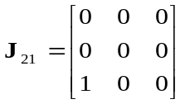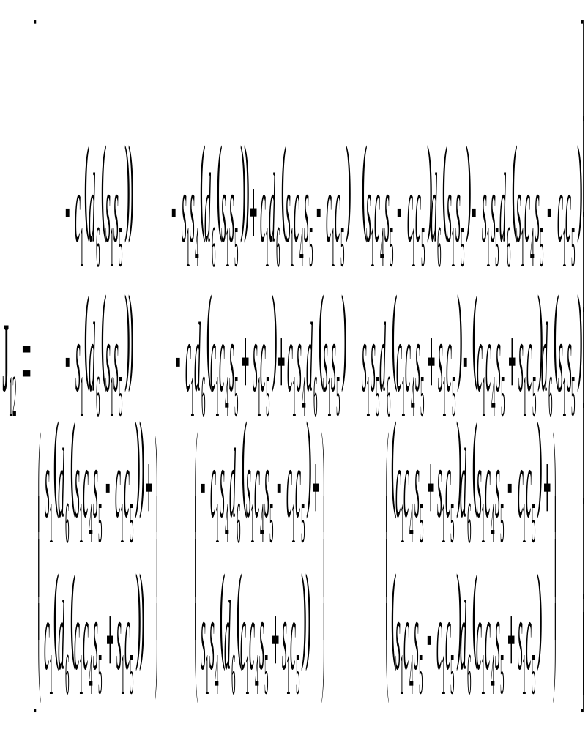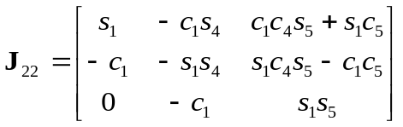

Singularities at det(J₁₁) = 0, det(J₂₂)=0
Example 7:
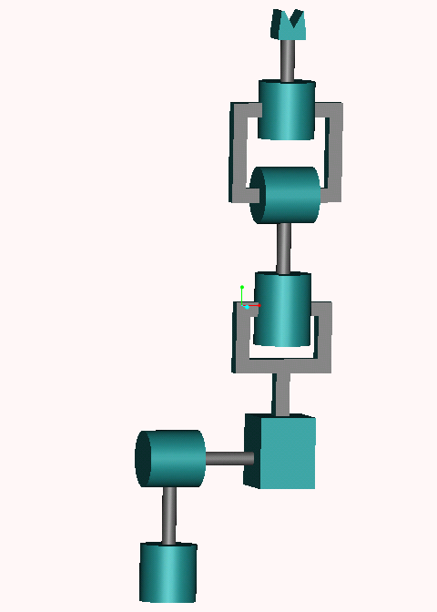
x₀
z₀
x₁
z₁
x₂
z₂
z₃
x₃
d₁
d₃
z₄
x₄
x₅
x₆
z₆
z₅
d₂
d₆
θ₅

θ₆
i | a_{i} | α_{i} | d_{i} | θ_{i}
1 | 0 | 90 | d₁ | θ₁*
2 | 0 | -90 | d₂ | θ₂*
3 | 0 | 0 | d₃* | 0
4 | 0 | 90 | 0 | θ₄*
5 | 0 | -90 | 0 | θ₅*
6 | 0 | 0 | d₆ | θ₆*
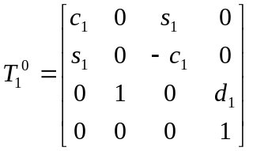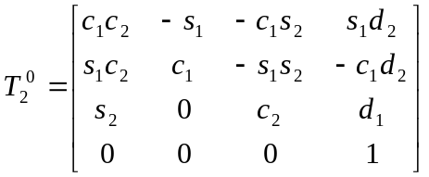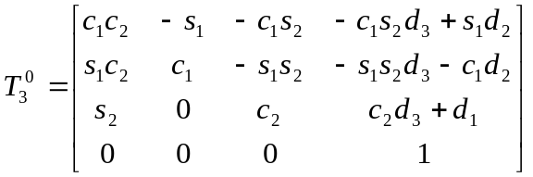
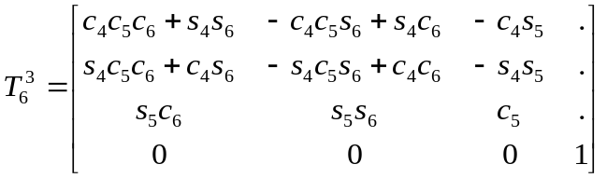
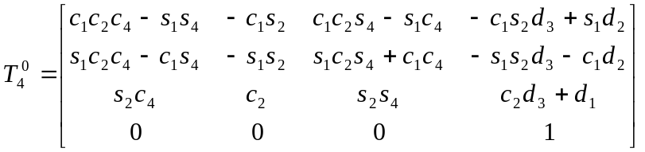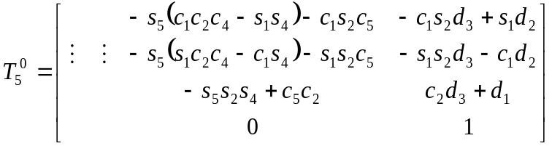
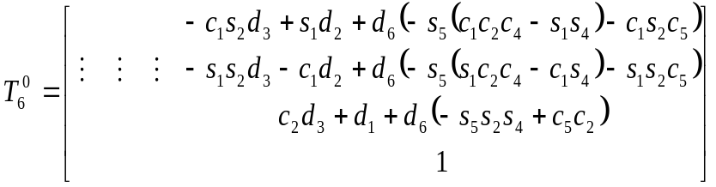

Determine Manipulator Jacobian: J_{6x6}
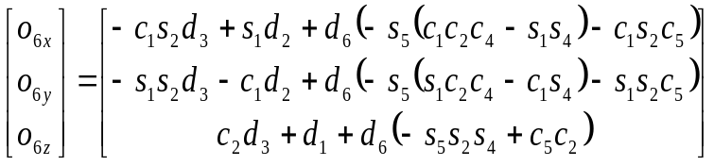
Joint 1 is revolute:
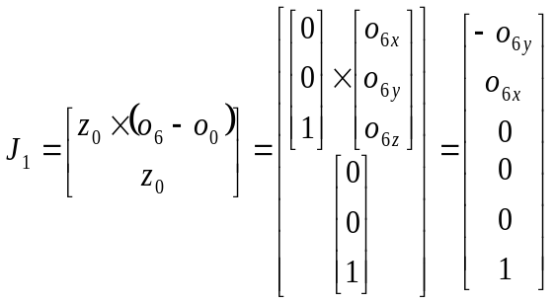

Joint 2 is a revolute:
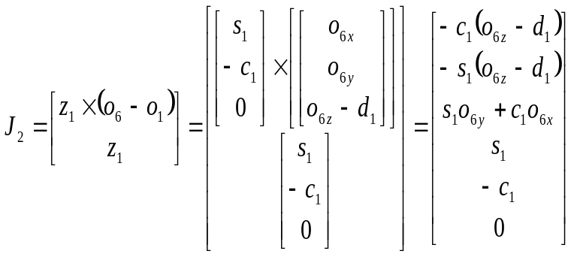

Joint 3 is prismatic:
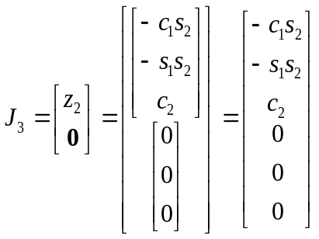
Joint 4 is revolute:
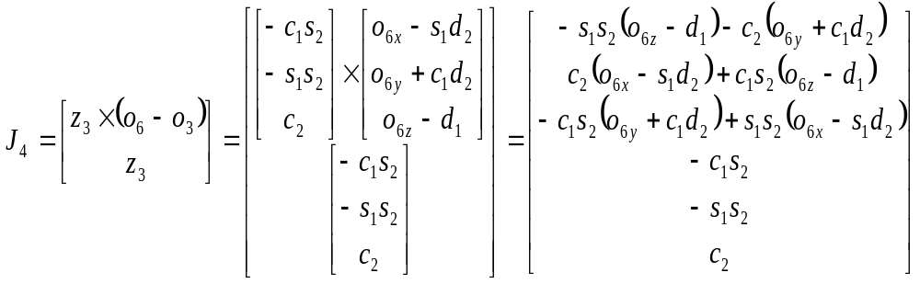
Joint 5 is revolute:
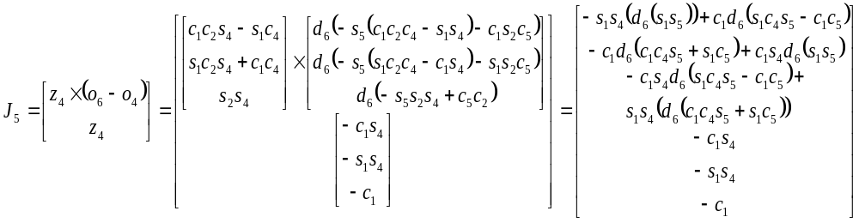
Joint 6 is revolute:
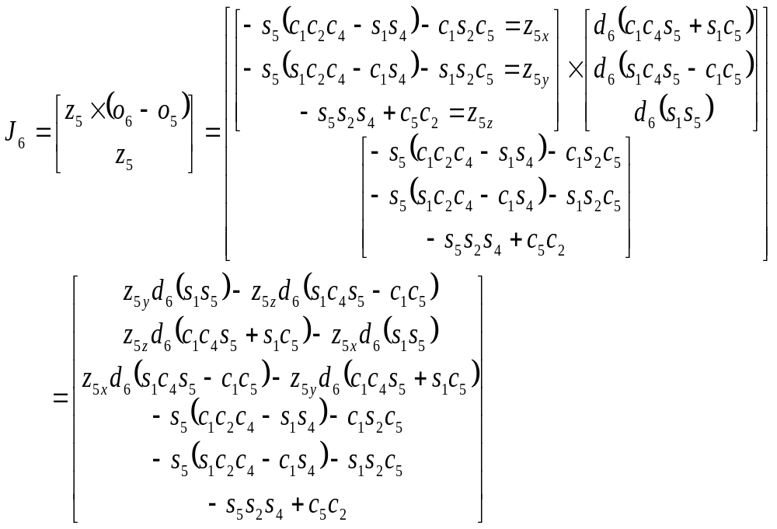
Jacobian:
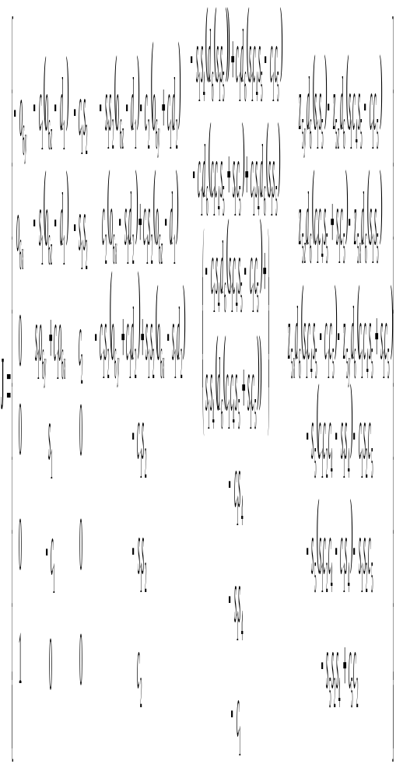 Partition:
with:
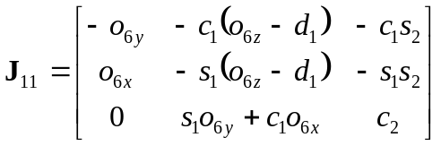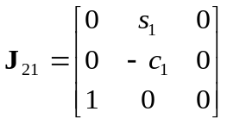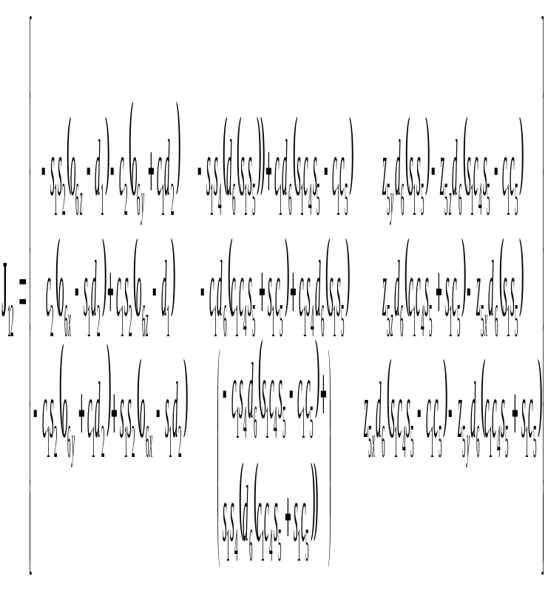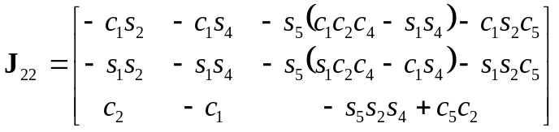

Singularities at det(J₁₁) = 0, det(J₂₂)=0

